**Southampton Solent University**

**Media Arts and Technology**

**Web Technologies**

**2016 - 2017**

**Huseyin Alanli**

**“Web Tec Report”**

**“Web Technologies Website Report”**

**Tutor: Prins Butt Student ID: Q10193626**

**Date: May 2017**

Table of Contents

Introduction 3

1. Responsive Design and User Experience 4

1.1 Responsive Design and User Experience 4

2. Client and Server Architecture 7

2.1 Web service 7

2.2 FTP & FileZilla FTP Client. 8

2.3 The Edward server 8

2.4 My SQL database Relationships 9

3. Web Technologies 10

3.1 HTML 10

3.2 CSS 11

3.3 JavaScript 11

3.4 Google Char API 12

3.5 PHP and MySQL 12

3.6 Front-end and Back-end 13

3.7 AJAX 13

3.8 Pages 14

4. Conclusion 16

5. References 17

6. Appendices 18

Figure 1: Responsive Design 4

Figure 2:Bootstrap Responsive Design 5

Figure 4: UX and Importance of Design 6

Figure 5: Server Architecture Model 8

Figure 6: Relationship Table 9

Figure 7: CSS Background Code 11

Figure 8: API Graph and live Time 12

Figure 9: Update Units using AJAX 14

Figure 10: Get users avatar 15

Figure 11: Assessments While loop 15

Figure 12: GET and POST PHP codes 15

# Introduction

Nowadays, there are endless devices around the world and each has different resolutions. Nearly every new clients wants a mobile version of their website. Also they want the website to be compatible with all screen resolutions. With more people than ever before browsing the web, opening email and shopping on their mobile devices, it is important to have a mobile friendly, responsive websites. The bounce rates will go higher and the ranking of the site will drop if the Website is not responsive and optimised for mobile browsing. (Wodehouse, 2015)

Web technology is interpreted with more scripting languages, i.e. If the web developer writes a code which is easily understandable by the web browsers. On the other-hand, compiled scripting languages needs translator to interpret the code into machine language code. Different web technologies have different server dependencies, so before choosing the particular web technology, determine the services hosted by that technology.

# 1. Responsive Design and User Experience

## Responsive Design and User Experience

Responsive Web design is when a user switches from their pc to smart phone, the website should have the technology to automatically respond to the users preferences. Particularly, the website should automatically switch to accommodate for scripting abilities, image size and resolution.

There are new devices with new screens developing everyday with varying screen resolutions. Some are in portrait and others are in landscape. However with the users whim nowadays, many new devices have abilities to switch from portrait to landscape. For these kinds of situations, websites that are not responsive become unusable. For this reason, the importance of responsive Web design must be considered. (SmashingMag, 2011)

Presently, developers can make things more flexible. Such as, images can be automatically adjusted, and the layouts never break but may become squished in the process. This gives users more options to switch their devices from portrait angle to landscape immediately. (See Figure 1)

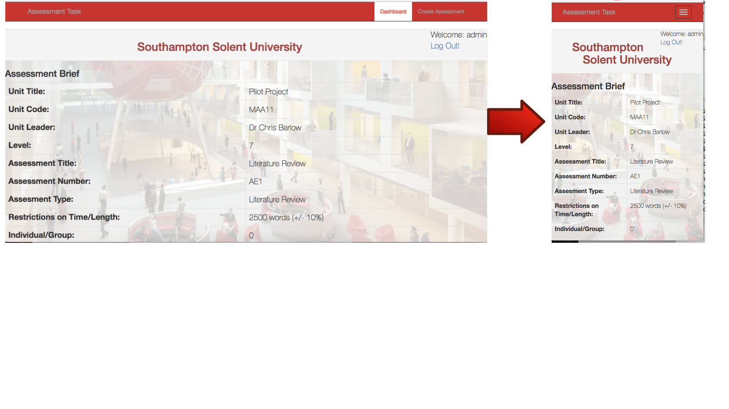

Figure : Responsive Design

Currently, Bootstrap framework is the most popular way to build responsive websites. There are some key features of the Bootstrap. One of the best features of the Bottstrap is grid-based layout approach. Which means that a developer can use up to 12 columns in a layout, combining them for wider columns, which are organised in layout classes of extra small, small, medium, and large for desktop sized screens, tablets and phones. (Mark Otto, Jacob Thornton) Also, Bootstrap is fast and easy to use. Most of the developers can build front ends without much knowledge of HTML or CSS. (See Figure 2)

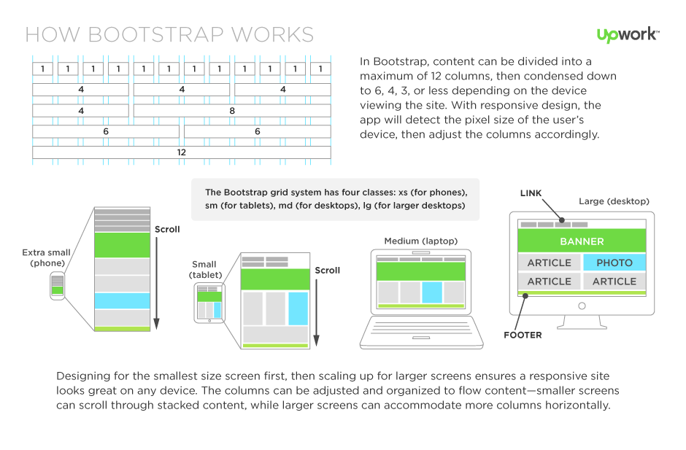

Figure :Bootstrap Responsive Design

On the developed website, first, the bootstrap applied for all of the pages. All the pages are responsive, however, it is mostly used on the view assessment page for the tables. (See Figure 3)

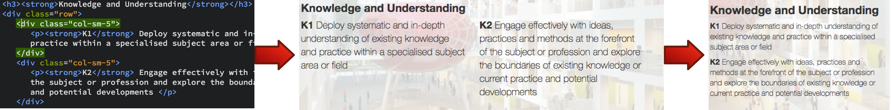

Figure : Bootstrap Code

Web design is not only about automatically resizable images and adjustable screens. User Experience (UX) Design is one of the most important parts of the design process. It is more focused on the overall experience of the users that the look of the look of the website. Before creating a website, developer must do a lot of research and planning to figure out what will be the content of the website and where things should go. User Experience is more about improvements of the website features after understanding users behaviours, feeling and emotions. (See Figure 4)

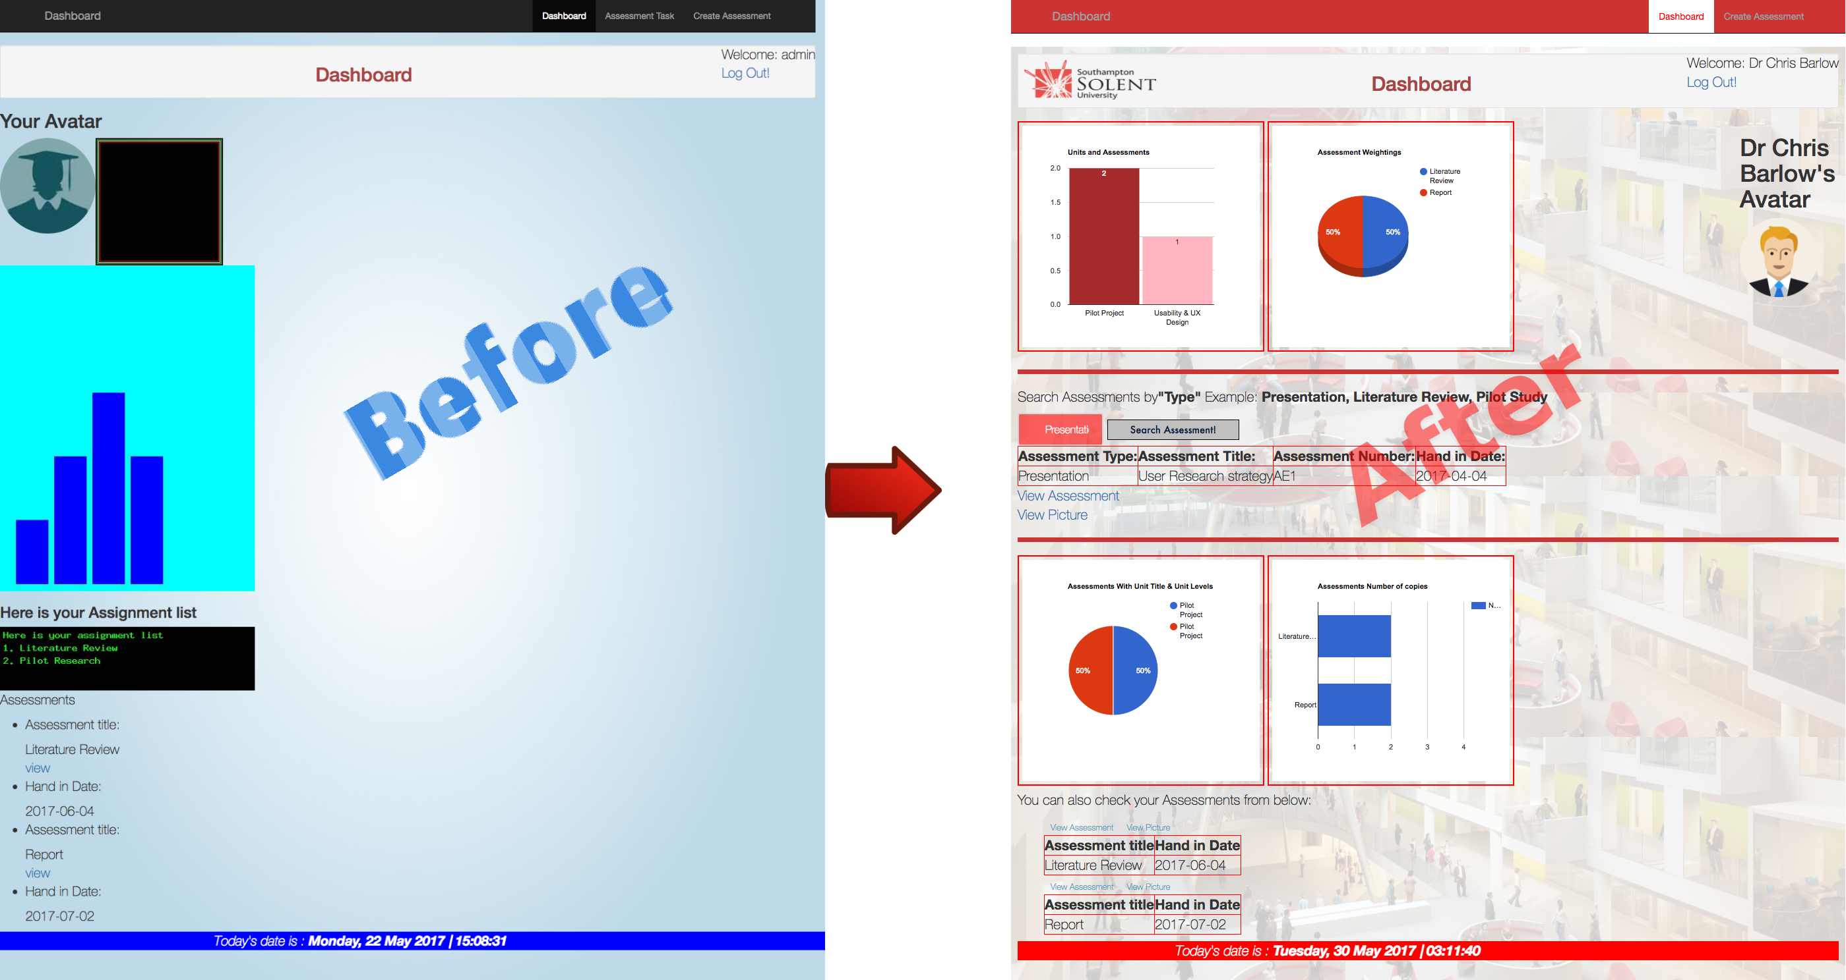

Figure : UX and Importance of Design

When elements move around the page, development and design need to work closely together to ensure a usable experience across devices. The user experience can be totally different from the each view of the site. As the content of the website is important, also the developer must see what the end result of that responsive moves looks like and how it will affect the user experience. The most importantly, for a successful responsive website, the testing across platforms and conducting a usability testing on designers is important and at the end, the design must be usable at all screen resolutions and sizes. (Schade, 2014)

# 2. Client and Server Architecture

## 2.1 Web service

Frist of all, Web services used mainly on the create page and view page, the web is service which is built on top of the Internet that allows the computers to share and exchange data easily and reliably. Such as documents, videos, images etc. For this reason, sometimes the web is referred to as Client-Server communication. Because, there are always computers that ask for data, which are, called the clients.

Furthermore, the computer who serves the data is called servers. A Client can be a machine and programs that users can access the web. For example machines it can be laptops, desktop computers, tablets, and smartphones. A client program is a program that allows the user to make request through the web. For example a web browser is a program because a user can make a request for a web page through the web browser. So, client weather it’s a machine or a program, is an appliance and a way to make request through the web. (*The Client Server Model | Clients and Servers* 2016)

Additionally, a server is a computer program and it is not a device. Servers provide functionality and serve other programs called clients. A single server can serve to multiple clients at the same time. There are several types of servers such as, Web servers (Apache) it serve HTTP request and Database servers, it runs a database management system such as MySQL and other types of servers.

A server can contain web resources and it can host web applications and it can store users and program data. It is used to serve a lot of clients. A server is always listening for request, and as soon as it receives one, it responds with a message.

Finally, the client-server model is just one way for the computers to communicate via the web. Client/server is a program relationship in which one program (the client) requests a service or resource from another program (the server). (Rouse, 2008) (See Figure 5)

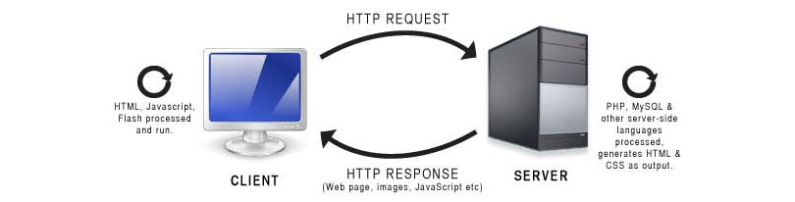

Figure : Server Architecture Model

## 2.2 FTP & FileZilla FTP Client.

In this project FileZilla used to upload files. FTP stands for File Transfer Protocol. It is a way of moving computer files from computer to special computers (Servers). A special computer is built to host and serve to others. Furthermore, When a person looking at to a website, websites are hosted on the servers and they are hosted online. For example, when a web developer created a website by using the Web Technologies, If the developer wants to view the created web page on the web, the developer must put the web page on to a web server, and the way to get that created website file to a web server is by using a File Transfer Protocol (FTP). (Parker 2005)

Moreover, FTP is not a program or a software application. FTP is just a method and in order to use this method the user need a specific type of computer program. That computer program is called a File Transfer Protocol client (FTP Client). There are a lot of choices of FTP clients around. In this project, FileZilla FTP client were used to transfer files from the computer to a web server. Finally, to use this the FileZilla FTP client, name of the server, FTP username and password was required.

## 2.3 The Edward server

It is also important to understand the web stack of used server. A web stack is a stack of software that all works together to serve and process web pages. Each server has own distinct stack. A common web stack will contain an operating system, a web server, a database server and a programming language. For example, the Edward server is used in this project is containing LAMP stack, which contains, Linux operating system, Apache web server, MySQL database server and PHP is the programming language. LAMP stack is most commonly used web stack on web servers. Also there are other common stacks such as, WAMP, WISA, MARS and etc.

## 2.4 My SQL database Relationships

An entity-relationship diagram (ERD) is a graphical representation of an information system that shows the relationship between people, objects, places, concepts or events within that system. Below diagram illustrates the relationship of the created database.

**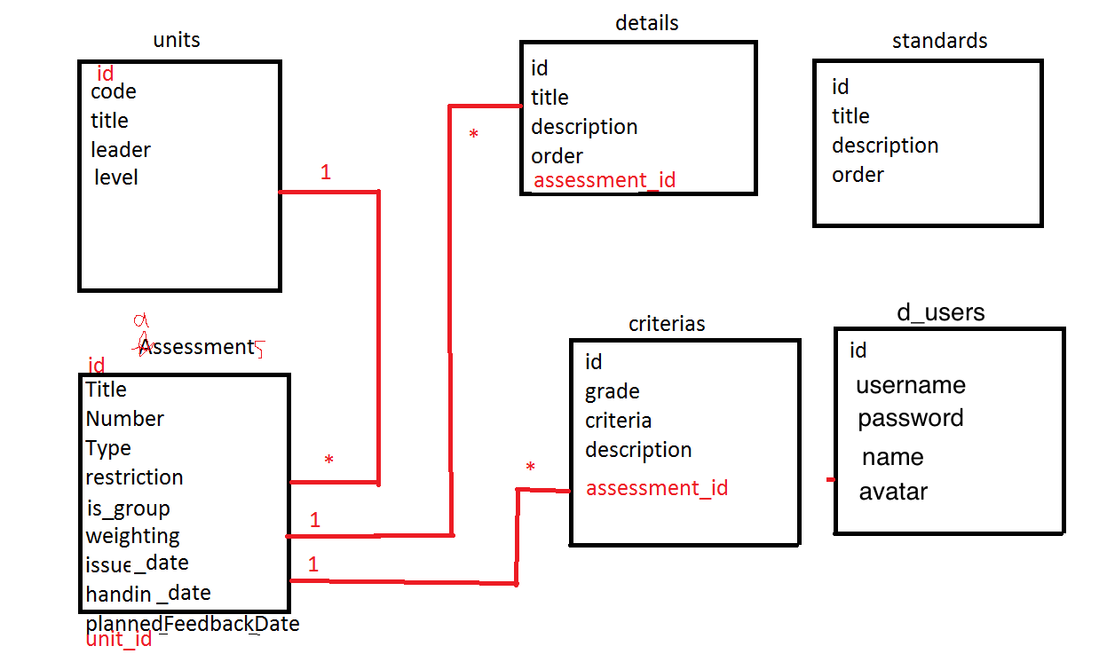**

Figure : Relationship Table

# 3. Web Technologies

The Client side scripting creates what user interact with on the website and server side scripting is typically the websites back end development. The database technology manages all the information on the server that supports a website and Mark-up languages are the backbone of all of these technologies. (Wodehouse 2016)

First of all, Web technologies means when computers are communicate with each other by using multimedia packages and mark-up languages. Mark-up is used to in text and word processing documents to describe how a document should look when displayed or printed.

In the past few decades, web technologies have undergone a dramatic transition from a few marked up web pages to the ability to do a very specific work on a network without interruption. The Internet uses mark-up to define how Web pages should look when displayed in a browser. Web technologies gives people a way to interact with hosted information like websites. It is also involves the use of hypertext mark-up language (HTML) and cascading style sheets (CSS).

## 3.1 HTML

HTML is stands for Hyper Text Mark-up Language. It is a mark-up language used for presenting and structuring content on World Wide Web. The Hypertext is the text on the web pages that does stuff when user clicks on it. For example when user reading a sentence, and sees an underlined clickable text in a different colour or other clickable pictures videos. Furthermore, Mark-up Language tells computers how to format documents. Today, there are a lot of mark-up languages such as, HTML, XML, XHTML and etc. HTML uses the hierarchy of tags to organise each piece of a website into its proper place. And the web browser takes the websites HTML code, interprets it and then displays it back to the users. (Wollin 2014)

## 3.2 CSS

CSS stands for cascading style sheets. It provides the ability to change the appearance of the text for example, spacing, colors and fonts on Web pages. Also, CSS has abilities to position elements on the page, to change the appearance of the browser such as changing the scroll bars and it can make certain elements hidden. (See below Figure)

For example when creating the website, background image styled with CSS. (See below Figure)

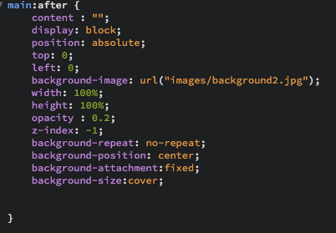

Figure : CSS Background Code

## 3.3 JavaScript

JavaScript is a popular programming language and widely used in the world. JavaScript can be used to program web browsers or the servers. JavaScript creates very rich interactivity such as gifs, graphs, live time and etc. JavaScript also has the advantage of working on many modern mobile devices

By combining HTML and CSS, It allows developers to create Dynamic HTML pages. It used on the Internet for creating Web pages that respond to user actions. (Harrison 2017) such as, API Graphs and Live time. (See Figure 8)

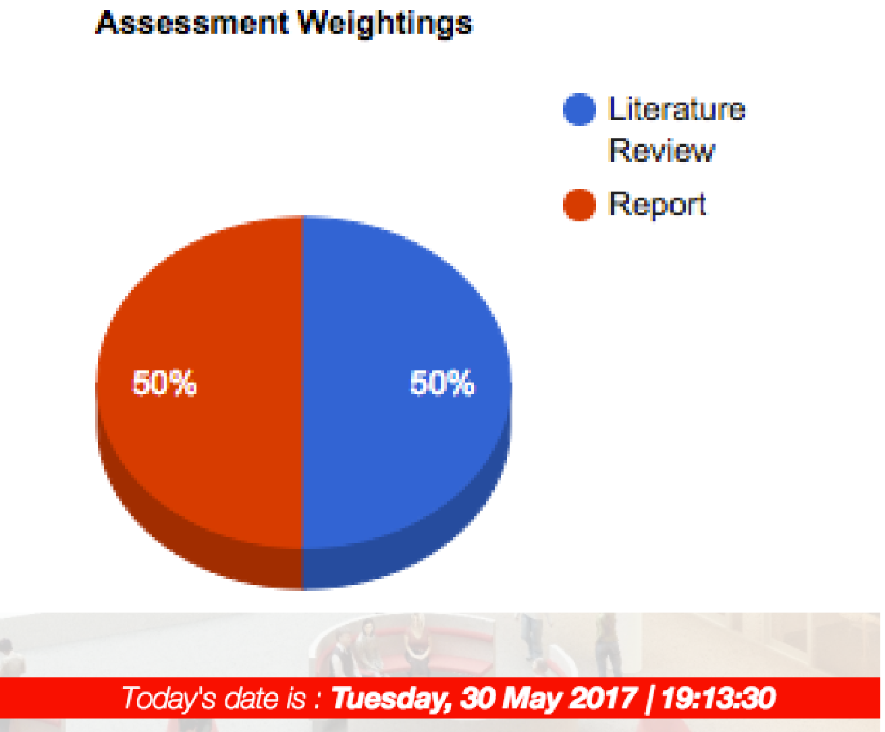

Figure : API Graph and live Time

## 3.4 Google Char API

The Google Chart API is an interactive Web service (now deprecated) that creates graphical charts from user-supplied data. Google servers create a PNG image of a chart from data and formatting parameters specified by a user's HTTP request. The service supports a wide variety of chart information and formatting. Users may conveniently embed these charts in a Web page by using a simple image tag.

Currently, line, bar, pie, and radar charts, as well as Venn diagrams, scatter plots, spark lines, maps, Google-o-meters, and QR codes are supported.

Google Chart API was used on the dashboard with retrieving the data from the databases from the users data. Use of PHP, JavaScript was essential. (See Appendix A)

## 3.5 PHP and MySQL

PHP is a server side scripting language used to develop Web Applications or Internet Applications. It is popular scripting language used in building dynamic sites. MySQL is an open source database server built based on a relational database management system. It is capable of handling a large concurrent database connection. (Wollin 2014)

When using PHP, web browser sends a request to the web server then the web server runs the PHP script, captures the HTML output of the script and sends that as the response back to the browser.

## 3.6 Front-end and Back-end

The front-end technologies can be combination of HTML, CSS and JavaScript, JQuery and AJAX or JSON. When starting to learn all of these web technologies, developer must pick a text editor such as, Brackets, Notepad++ and Atom. In this project, the web developer chosen the Brackets because it is a great text editor for beginners and it feels little bit confortable from the others. In order to make the server, application, and database communicate with each other, back-end developers use server-side languages Such as, **PHP**, MySQL, SQL server to find, save, or change data and serve it back to the user in front-end code. (Wales 2014)

## 3.7 AJAX

Ajax can be used to submit forms and to get feedback from that form without having to refresh the page. It is stands for Asynchronous JavaScript and XML. For example, when using a form html page without using an Ajax, when user clicks to submit button that would bring the user to another page. However with AJAX, when clicking the submit button, it talks to a JavaScript function that has an AJAX function in it. Then that will talk to PHP, after that PHP will talk to the Database. After all of these, the database goes back to the PHP and tells all the values that the PHP asked for, and then the PHP will go back to the JavaScript function which will then go back to the HTML page and display the data in the div that the developer want.

This is very useful and fast way to illustrate information from the database. Also you don’t need to load more content.

In the development of the website, First, AJAX used for the signup, and create page. After more practicing of how AJAX works. The developer was able to retrieve the data with a search box on the dashboard page The AJAX table was created on the Create Assessments page to edit, insert and delete the data from the database.

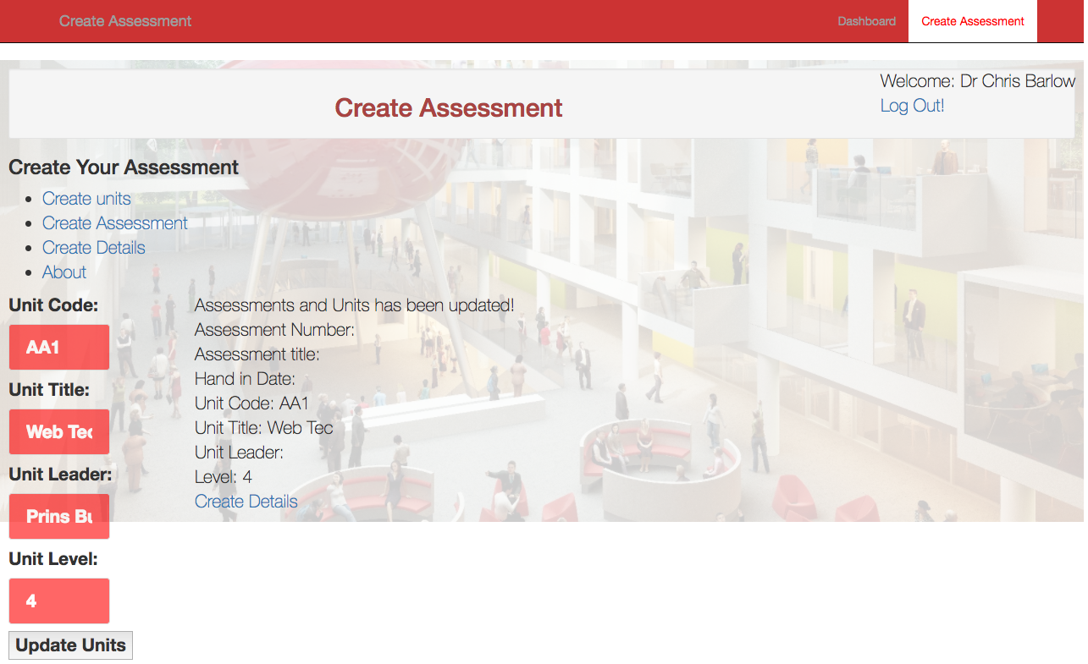

Figure : Update Units using AJAX

## 3.8 Pages

When user is goes to signup an account, they must fill the form and create their account. When The Login and Signup pages were designed, use of HTML, CSS, Bootstrap, PHP, AJAX was essential.

CSS and Bootstrap was used to design the page layout, colour scheme, fonts and navigation bar. The HTML form was created for the user to create their account by filling the form.

HTML form allows the user to enter their information and the Web page sent the information to the server for processing with “processform.php” to insert the users information by.

When using the login page, Form allows users to fill their information and the connected PHP file selects the data from the database server and if the data is correct, it directs the users to their dashboard.

Also when user is directed to the dashboard, the $\_GET gets the user id and by “$\_SESSION["gatekeeper"] = $userRecord[id];“ it remembers the logged in user.

On the dashboard, user’s avatar, user’s name retrieved and showed from the databases.

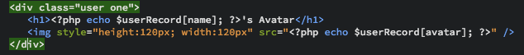

Figure : Get users avatar

Also, on the dashboard, user can see their Assessments. The assessments retrieved by their id’s from the database by creating the while loop. When viewing the assessment details from the links, assessment id is gathered.(See below Figure)

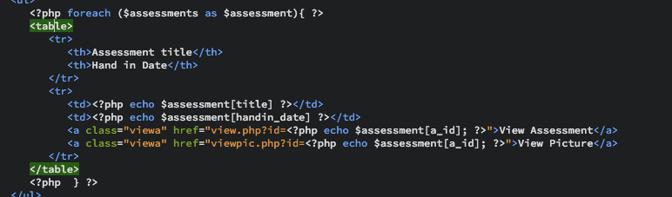

Figure : Assessments While loop

In case of forms the difference between GET and POST has more to do with convenience and the fact that both methods fit to certain use cases and not with the fact whether a some resource is created/changed on the server.

GET is good when the request is cacheable and/or bookmarkable. However, in most HTML form cases, POST seems always better, especially when dealing with long data (eg. forum post).

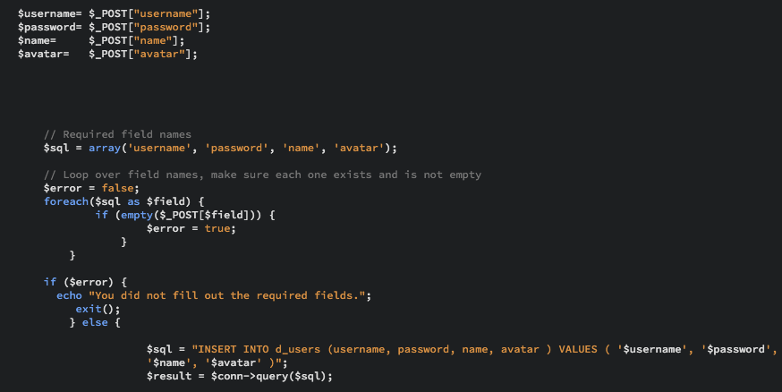

Figure : GET and POST PHP codes

When creating assessments, when user choosing the unit title from the dropdown list, it loops all the units from the database by unit’s id.

# 4. Conclusion

In Conclusion, Web technologies are important and every web developer to have a basic knowledge of them. Creating state-of-the-art web applications that work well regardless of the user's platform and browser has always been a challenge. The created website should satisfy the users of the website and it should give them what they need. By providing an extremely graphical user interface, also the design is important. Flexibility in design makes user explore their imagination. Finally, Web technologies can find solutions to problems in the future.

# 5. References

HARRISON, J., 2017. How Do HTML, CSS and JavaScript Work Together? In: *ITonlinelearning.*May 11, [viewed May 28, 2017]. Available from: [https://www.itonlinelearning.com/blog/how-do-html-css-and-javascript-work-together/](https://www.itonlinelearning.com/blog/how-do-html-css-and-javascript-work-together/" \t "_blank)

ROUSE, M., 2008. What is client/server (client/server model, client/server architecture)? - Definition from WhatIs.com. *SearchNetworking,*

MARK OTTO, JACOB THORNTON *Grid system*[viewed May 23, 2017]. Available from: [https://v4-alpha.getbootstrap.com/layout/grid/](https://v4-alpha.getbootstrap.com/layout/grid/" \t "_blank)

PARKER, D., 2005. *Understanding the FTP Protocol - TechGenix*[viewed May 28, 2017]. Available from: [http://techgenix.com/understanding-ftp-protocol/](http://techgenix.com/understanding-ftp-protocol/" \t "_blank)

*Responsive Web Design: What It Is And How To Use It - SmashingMag*2011. [viewed May 23, 2017]. Available from: [https://www.smashingmagazine.com/2011/01/guidelines-for-responsive-web-design/](https://www.smashingmagazine.com/2011/01/guidelines-for-responsive-web-design/" \t "_blank)

SCHADE, A., 2014. *Responsive Web Design (RWD) and User Experience*[viewed May 23, 2017]. Available from: [https://www.nngroup.com/articles/responsive-web-design-definition/](https://www.nngroup.com/articles/responsive-web-design-definition/" \t "_blank)

*The Client Server Model | Clients and Servers,*2016 Directed by Ayoub NEJJARI. May 20,

WALES, M., 2014. *Front-End vs Back-End vs Full Stack Web Developers*[viewed May 28, 2017]. Available from: [http://blog.udacity.com/2014/12/front-end-vs-back-end-vs-full-stack-web-developers.html](http://blog.udacity.com/2014/12/front-end-vs-back-end-vs-full-stack-web-developers.html" \t "_blank)

WODEHOUSE, C., 2015. What is Bootstrap 3? - Front-End Framework - Responsive Mobile First Sites. *Hiring | Upwork,*

WODEHOUSE, C., 2016. *Web Programming Language Basics Explained*[viewed May 28, 2017]. Available from: [https://www.upwork.com/hiring/development/web-development-languages-101/](https://www.upwork.com/hiring/development/web-development-languages-101/" \t "_blank)

WOLLIN, L., 2014. Introduction to Web Technologies for FrontPage Users.

# 6. Appendices

6.1 Appendix A

Dashboard

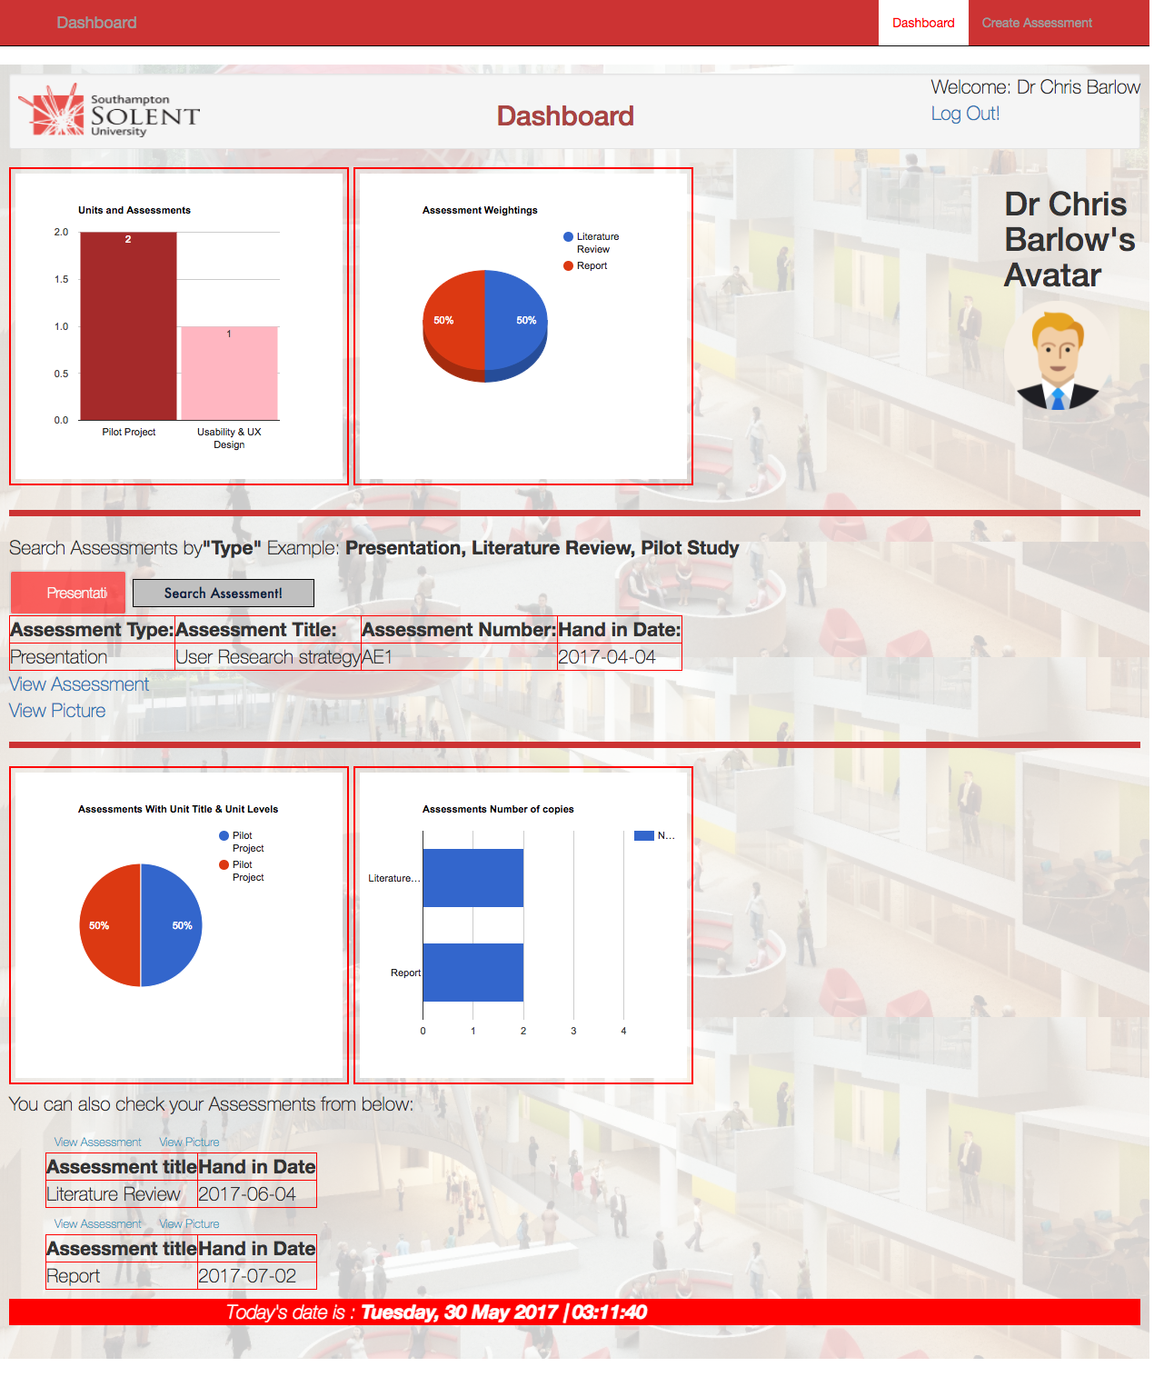

Create Page

